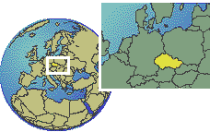
- 18. May 2003 Arrival in Carlsbad

All members / friends of the Route Orient 2003 will fly in to Carlsbad airport on
May, 18th. 2003 between 12:00 – 14:00 UTC. Everybody takes own transportation (taxi) to the nearby Park Hotel Pupp www.pupp.com
Reception will take place at 19:00 local (17:00 UTC) in the Hotel.
Will have all the time to get familiar, talk about the trip, etc.

May 19th 1day excursion to Cheb, Marianske Lanze, Frantiskovy Lanze, etc.

Czech Republic, republic comprising the historical regions of Bohemia and Moravia and part of Silesia in central Europe, bounded on the north by Poland, on the east by Slovakia, on the south by Austria, and on the west and north by Germany. Formerly part of Czechoslovakia, the Czech Republic and Slovakia emerged as independent republics on January 1, 1993. The Czech Republic has an area of 78,864 sq km (30,450 sq mi). Prague (Czech Praha) is its capital and largest city.
Carlsbad is the largest and best-known bath resort in the Czech Republic.
The town is located not far off the Czech-German border on the international road E48, 60 km from border town Schirnding. The distance between Carlsbad and Prague, the Czech capital, is 125 km. Carlsbad can be reached via train through border crossing Schirnding - Cheb, or through Johanngeorgenstadt.
Founding Carlsbad, Charles IV, Czech King and Roman Emperor, could not anticipate he was founding a bath resort, which would become world-famous. In the six centuries that followed, the town was both flourishing and declining according to whether Europe was thriving in time of peace, suffering in times of war, or quivering with fear in times of raging pestilence. The face of Carlsbad was also badly hurt by large fires and floods. But every disaster was followed by a period of renewal, during which the town usually grew more beautiful than ever before. 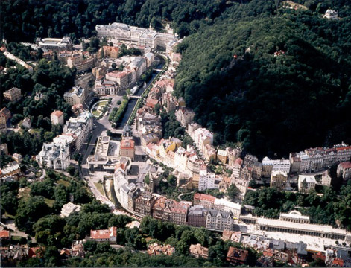
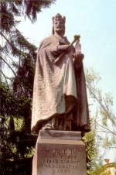
The most famous period of Carlsbad is that of the second half of 19th and of the beginning of 20th century. At this time, the town also has got the best part of its unique architecture, which is admirably harmonised with surrounding scenery. But in addition to the beauty and history of the town, the "world credit" of Carlsbad was formed particularly by its unique natural resources - Carlsbad mineral springs. The renowned Hot Spring (Vřídlo) has been celebrated by poets of past ages and for many invalids it has represented their last hope for recovery. The praise of many people who have recovered thanks to the Carlsbad springs carried the fame and good reputation of the town all over the world.

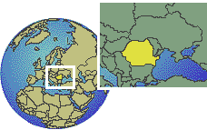

- 20. May 2003 Depature Carlsbad for Bucharest (Romania)

2 nights in the area of Bucharest.
Accommodation will be Hotel Continental www.continentalhotels.ro

May 21st; 1 day sightseeing tour in Bucharest visiting Victoria Avenue, Officers Club, Cismigiu Gardens and Parliament Palace (second biggest in the world after the Pentagon in Washington).

Romania, republic in southeastern Europe, bounded on the north by Ukraine; on the east by Moldova; on the southeast by the Black Sea; on the south by Bulgaria; on the southwest by Serbia (part of the federation of Serbia and Montenegro); and on the west by Hungary. The total area of Romania is about 237,500 sq km (about 91,699 sq mi). Bucharest is Romania's capital and largest city.
Bucharest (Romanian Bucureti), capital and largest city of Romania, located in the southeastern part of the country. The city is situated about 65 km (about 40 mi) north of the Danube River, near Ploieti, on the banks of the Dâmbovia River (a tributary of the Danube). Bucharest lies on a generally level plain and, including suburban districts, occupies an area of about 300 sq km (about 117 sq mi).
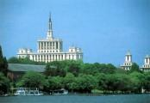

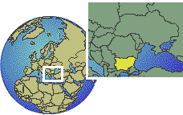

- 22. May 2003 Depature Bukarest for Burgas (Bulgaria)

2 nights in Hotel Villa List in Sozopol. www.kras.net/Tur/new_oblasti/ID/Vila_list.htm

May 23rd ; 1day excursion to Nessebur (historical village) and UNESCO world cultural heritage.
Bulgaria, republic in south eastern Europe, known from 1946 to 1990 as the People's Republic of Bulgaria. Situated in the Balkan Peninsula, Bulgaria is bounded on the north by Romania, on the east by the Black Sea, on the south by Turkey and Greece, and on the west by Serbia (part of the federation of Serbia and Montenegro) and the Former Yugoslav Republic of Macedonia. Once an independent kingdom, Bulgaria was dominated by the Communist party from 1946 until 1990, when a multiparty system was adopted. During the Communist period, when Bulgaria was under the control of the Union of Soviet Socialist Republics (USSR), the once-dominant agricultural sector was overtaken by manufacturing. The capital and largest city is Sofiya. The area of Bulgaria is 110,912 sq km (42,823 sq mi).
Burgas, city in eastern Bulgaria, capital of Burgas Province, a seaport on the Gulf of Burgas (an inlet of the Black Sea). The surrounding region is chiefly agricultural. The city has a good harbor and is connected by rail, through Sofiya, with the general European railroad system. The major part of Bulgaria's Black Sea grain trade passes through Burgas, and trade in other agricultural products is second only to that of Varna. The city's fish-processing industry handles most of Bulgaria's fish 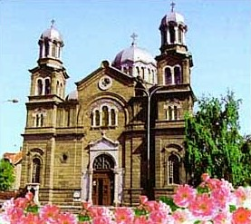 harvest. The city also has flour and sugar 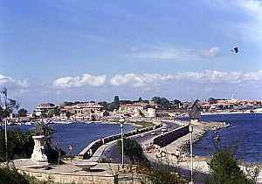 mills. Population (1990 estimate) 204.915..

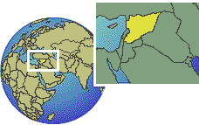

- 24. May 2003 Depature Burgas for Aleppo (Syria)
- with a stop in ANDANA for refuelling

2 nights in Hotel Beit Wakil http://www.beitwakil.com/
May 25th ; 1 day excursion in Aleppo.

Syria (Arabic Suriyah), officially Al Jumhuriyah al Arabiyah as Suriyah (Syrian Arab Republic), republic in southwestern Asia, bounded on the north by Turkey, on the east by Iraq, on the south by Jordan and Israel, and on the west by Lebanon and the Mediterranean Sea. Syria has an area of about 185,050 sq km (about 71,498 sq mi). The capital and largest city is Damascus, also spelled Dimashq.

Halab or Aleppo (ancient Beroea), city in northern Syria, capital of Halab Governorate. It lies on a plateau 427 m (1400 ft) high, midway between the Mediterranean Sea and the Euphrates River. The second largest city of Syria, Halab is an agricultural trading center and has factories producing carpets; silk, cotton, and wool textiles; silverware and gold ware; leather goods; and embroidery. Halab consists of an old and a new town; the former is enclosed within a wall dating from medieval times. Among the most important buildings are the modern citadel, surrounded by a moat and standing on a hill 61 m (200 ft) high, and the Mosque of Zacharias, said to contain the tomb of Saint John the Baptist's father. Also in Halab are a number of European schools and Christian churches and missions. The University of Halab was founded in 1960. The city is connected by rail with Damascus, and with Bayrt, Lebanon, and by caravan route with Iraq and parts of Kurdistan. In the 3rd century AD, Halab became the greatest center of trade between Europe and lands farther east. The history of the city, which was settled by the Hittites before 1000 BC, parallels that of Syria. Population (1992 estimate) 1,445,000.
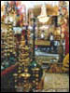
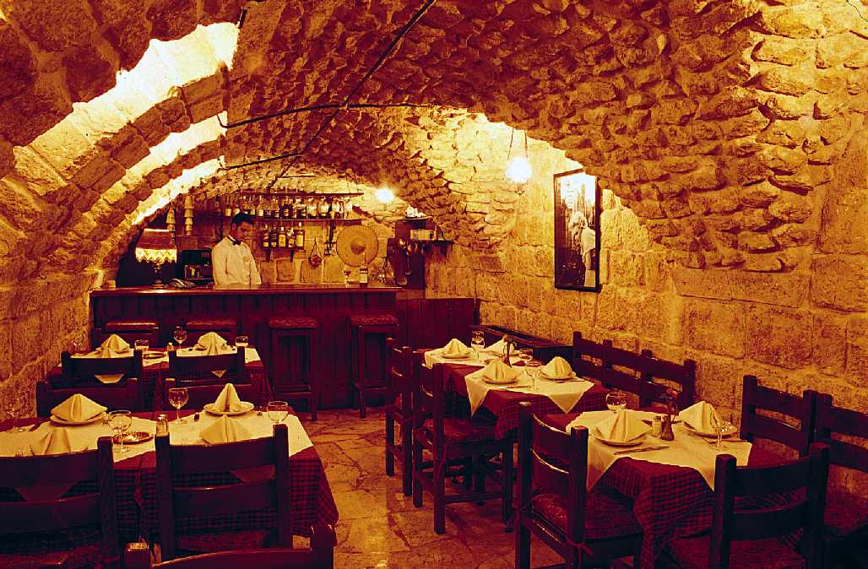

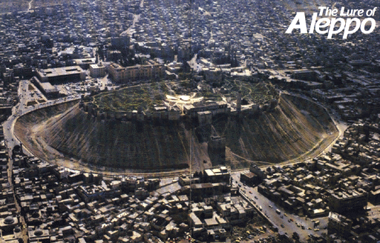

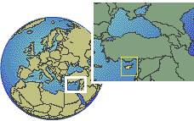
- 26. May 2003 Depature Aleppo for Larnaca (Cyprus)

2 nights Sandy Beach Hotel www.hotelworld.com

May 27th ; 1day excursion to Kolossi Castle and wine tasting, and further to Curium with lunch in Omodhos Village, etc.

Cyprus, republic, and third largest island in the Mediterranean Sea, located west of Syria and south of Turkey. The island has a maximum length of about 225 km (about 140 mi) from Cape Andreas in the northeast to the western extremity of the island. Its maximum width, from Cape Gata in the south to Cape Kormakiti in the north, is about 97 km (about 60 mi). The total area of the country is 9251 sq km (3572 sq mi). Nicosia is the capital and largest city. Since 1974 the northern third of Cyprus has been occupied by Turkish troops and has formed a separate—though officially unrecognized—state called the Turkish Republic of Northern Cyprus.

In 1960, Cyprus became independent from the British who had annexed it in 1914. Its new constitution apportioned power between the 80% Christian Greek majority and the 18% Muslim Turkish minority according to their respective populations.
This did not satisfy the latter who withdrew from the government in 1963 and refused to recognize its authority. In 1974 Turkey invaded, seized control of the northern third of the island and unilaterally declared the "Turkish Republic of Northern Cyprus". The island has been in a state of suspended civil war ever since with a no man's land separating the armed positions of both parties.

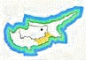LARNAKA: Town of Kimon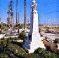
On the edge of Larnaka Bay the palm-lined seafront of Larnaka town bustles with cafes, tavernas, shops and bars. Historic charm is lent to the scene by its fortress castle, now used as the town's summer cultural centre. Larnaka is an excellent base from which to get to know the central and eastern section of Cyprus, and its proximity to the International Airport and a number of luxury hotels that have been developed along its beautiful sandy beaches make this a popular holiday choice. Larnaka was originally known as Kition, or Khittim, and legend has it that the first settlement at the spot was founded by Noah's grandson Khittim. But the name Larnaka probably comes from the Greek word "Larnax", which means sarcophagus many of which have been unearthed in this area.
The town's heyday was as an ancient city kingdom established by the Mycenean Greeks in the 13th century BC, when it enjoyed the dual position of rich sea port and major centre of the copper trade. Remains of that period excavated in recent years can be seen in its Cyclopean walls and a complex of Mycenean temples at the ancient Kition site.
Birthplace of the stoic philosopher Zeno, Larnaka was also the second home of St. Lazarus, who arrived there after his resurrection and later became its first Bishop. The Church of St Lazarus standing in the centre of the town is well worth a visit The tomb of St Lazarus, who is still the patron saint of Larnaka, is under the sanctuary. The town was not to regain its standing until the 17th century, when it became the consular and commercial centre of Cyprus, and i's port once again flourished with trade It was here that the British landed in 1878 to begin their rule of the island.

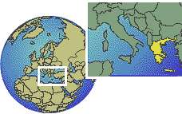

- 28. May 2003 Depature Lanarca for Kalamata (Greece)

2 nights in Hotel REX www.rexhotel.gr

May 29th ; 1 day boat trip to the Sfaktiria island with lunch in Finikoundas and take your time for a bath. Backtrack to Agios, Andreas to Kalamata.

Greece (Greek Hellas), officially known as the Hellenic Republic (Greek Ellinikí Dimokratía), country in southeastern Europe, occupying the southernmost part of the Balkan Peninsula and numerous islands. It is bordered on the northwest by Albania, on the north by the Former Yugoslav Republic of Macedonia and by Bulgaria, on the northeast by Turkey, on the east by the Aegean Sea, on the south by the Mediterranean Sea, and on the west by the Ionian Sea. The total area is 131,957 sq km (50,949 sq mi), of which about one-fifth is composed of islands in the Aegean and Ionian seas. Athens is the capital and largest city.
The mainland portion of Greece comprises the regions of Thrace and Macedonia in the north; Epirus, Thessaly (Thessalía), and Central Greece in the central section; and, in the south, the Pelopónnisos (Peloponnesus), a peninsula, which is connected to the rest of the mainland by the Isthmus of Corinth. The Corinth Canal, completed in 1893, passes through the Isthmus of Corinth, making an artificial island of the Pelopónnisos. The remainder of Greece consists of islands, which include Euboea (Évvoia); Crete (Kríti); the Northern Sporades; the Cyclades, Dodecanese, and Ionian Islands; and Ikaría (Icaria), Khíos (Chios), Límnos (Lemnos), Lésvos (Lesbos), Sámos (Samos), Samothráki (Samothrace), and Thásos.
The coastal waters of Greece are shallow and penetrate far inland. The gulfs of Corinth and Saronikós, separated by the Isthmus of Corinth, divide the Pelopónnisos from central and northern Greece. The country, despite its indented coasts, has few good harbors. The Gulf of Saronikós has the best anchorages, notably in the fine natural harbor of Piraiévs (Piraeus), which is the port of Athens. Kérkira (Corfu), one of the Ionian Islands, also has an excellent harbor.
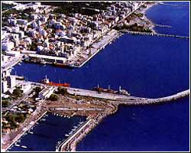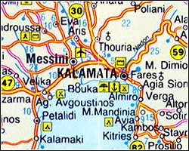
Capital and chief port of the prefecture of Messinia, built in the heart of the Messinian Gulf near the ancient city of Farai mentioned by Homer, 238 km from Athens, the land of Kalamatianos dance and the silk kerchief. Of succulent black olives, honey eyed figs and the sesame covered sweet called pastelli.
The town is dominated by the 13th century castle above it built by Geoffrey Villehardouin. On the north side of the citadel there is a small Byzantine church dedicated to the Virgin of Kalomata (of good eye), from which the town may have acquired its name. From the castle you can survey the expanse of sea below with its sandy and pebbly shores or turn your gaze upon the deep green plain, the "happy land" of the ancients.
The old city is spread out underneath the castle. This is where the Byzantine church of the Virgin Ypapanti and the convent of the Kalograies built in 18th century, where the nuns weave the famous Kalamata silk, are situated.
In 1209 it was proclaimed seat of a barony and held by the Franks up to 1381, when it had been taken over by Navarrese and later liberated by the Paleologues.
Turkish rule followed, except for an interval between 1685 and 1715, when it belonged to the Venetians.

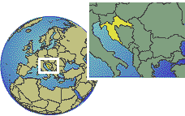

- 30. May 2003 Depature Kalamata for Dubrovnik (Croatia)
2 nights in Hotel Albatros www.hotelicavtat.hr

May 31st ; a 1 day boat trip to island Mljet the most famous in the Adriatic Sea.

Croatia (Croatian Hrvatska), republic in southeastern Europe, in the Balkan Peninsula, bounded on the north by Slovenia and Hungary, on the east and south by Bosnia and Herzegovina, and on the east by Serbia (one of the republics of the federation of Serbia and Montenegro). The area around the Croatian city of Dubrovnik, located at the tip of the republic's southernmost coastal stretch, has a short border with Montenegro. The Adriatic Sea forms the republic's long western boundary. Formerly a constituent republic of Yugoslavia, Croatia declared its independence in 1991. Civil war then broke out in the republic as ethnic Serbs, backed by the federal Yugoslav People's Army, battled with Croats for territory; Serbs controlled about 20 percent of Croatia's territory in mid-1995. Croatia has an area of about 56,538 sq km (about 21,829 sq mi). Zagreb is the republic's capital and largest city.
Dubrovnik (Italian Ragusa), coastal town in southeastern Croatia. Once a historic and picturesque town on the Dalmatian coast, Dubrovnik was known as a major tourist resort on the Adriatic Sea until much of the town was destroyed during the 1991 war between the republics of Croatia and Serbia. The town faces the sea at the foot of rugged limestone mountains and is notable for its medieval double walls and fortifications. Historical buildings included a rector's palace, two monasteries, and one of the oldest pharmacies (1317) in Europe. Dubrovnik has harbor facilities in the suburb of Gru. Silk and leather are manufactured in Dubrovnik, and exports include foodstuffs and timber.
The town was founded in the 7th century on a site called Ragusium by the Romans. It was under the protection of the Byzantine Empire between 867 and 1205, of Venice until 1358, of Hungary until 1526, and of the Ottoman Empire until 1806, but it governed itself as an independent republic. In the 16th century, Dubrovnik had one of the greatest merchant fleets in the Mediterranean, and it remained the chief cultural center for the South Slavs until the 19th century. Napoleon abolished the city-republic of Dubrovnik in 1808, and the 1815 Congress of Vienna gave the town to Austria. By the terms of the Treaty of Rapallo, signed in 1920 following World War I (1914-1918), the town became part of the newly created Kingdom of the Serbs, Croats, and Slovenes (later Yugoslavia). During World War II (1939-1945), Dubrovnik was occupied by the Italians and Germans. In 1991, when Croatia declared its independence from Yugoslavia, Serbian militias laid siege to and bombarded the town, destroying many sites of historical importance. Much of the population was forced to flee. Population (1991) 49,728.
Geographic position
The city of Dubrovnik is situated in the very south of the Republic of Croatia. It occupies an area of 364.05 square kilometres from Duboka Ljuta gorge - near the village of Plat to the east, to Imotica to the west, a distance of 53 kilometres.
The city of Dubrovnik encloses the tiny Elaphite archipelago (Šipan, Lopud, Koločep, Tajan, Olipa, Jakljan and Daksa).
Population
A population of 55.638 inhabits the area in 35 locations with 17.480 households at an average density of 152 inhabitants per square kilometre.
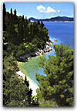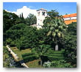

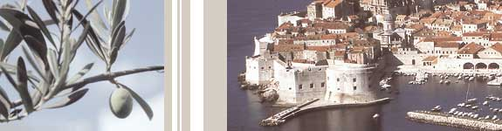

- June 2003 Depature Dubrovnik for your Hombase

End of journay

